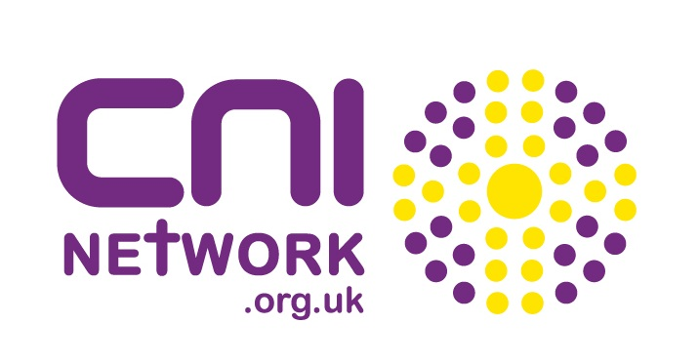
International Day of Prayer for the Night-time Economy
Sunday 26th February 2017 - Resources for Church Services

Bible Passage:

Your people will rebuild the cities that were destroyed long ago.
And you will build again on the old foundations.
You will be called the one who repairs broken walls.
You will be called the one who makes city streets like new again.

Isaiah 58:12 - The Bible

Video Resources:

https://www.youtube.com/watch?v=qRWumDIEdm4 - Manchester Street Angels on BBC 1’s City Christmas

www.youtube.com/watch?v=HfG1mymgh6k - BBC Newsnight feature Street Angels Magaluf

https://youtu.be/udj0d_rG2GU - BBC Street Patrol follows a Club Angels team

www.youtube.com/watch?v=ia1xyL0OE-A - Festival Angels at work, Leeds Festival

Prayer Pointers:

Include the points of the celebration:

- work we do on the streets
- those we help
- our volunteers in our 130 local CNI projects and for those who volunteer as Street Pastors, homelessness work, addiction support, etc
- great partnerships with a wide range of organisations
- that alcohol related violence and A&E admissions are reducing year on year in the UK
- that the church is at the heart of change within the night-time economy

Include the points for prayer:

- further significant reductions in violent crime and anti-social behaviour
- the night-time industry and its workers
- situations around human trafficking, binge drinking, depression, etc
- CNI Network as we expand to new towns and countries and support new project ideas
- partner organisations including Police, Fire, etc and for improved links
- work with young people around alcohol and safety
- finances for local projects and the international CNI Network

Prayer:

Lord as we pray ‘God’s Kingdom come, God’s will be done, on earth as in heaven’ help us to be people who make that a reality for our communities. We thank you for the work that happens at night in communities across the UK and overseas to help make this prayer a reality. We pray for every single person who has received help from one of the Street, Club or Festival Angel volunteers. We pray for those caught up in a life of addiction - that freedom may be found. We pray for those who volunteer to serve you at night - for strength, energy and wisdom. Thank you that alcohol related crime and A&E admissions are reducing in the UK year on year - we give you the glory Lord for this, the changed lives and changed communities. Amen!

Speaker:

You may like to invite a representative of your local project to share about the work in your local town. A list of local projects within the CNI Network family is at www.cninetwork.org.uk .

Alternatively use the video resources above to highlight the work of the church across the UK which is making a significant difference within the UK.

Web Sites:

CNI Network:
www.cninetwork.org.uk / www.facebook.com/cninetwork / www.twitter.com/cninet

