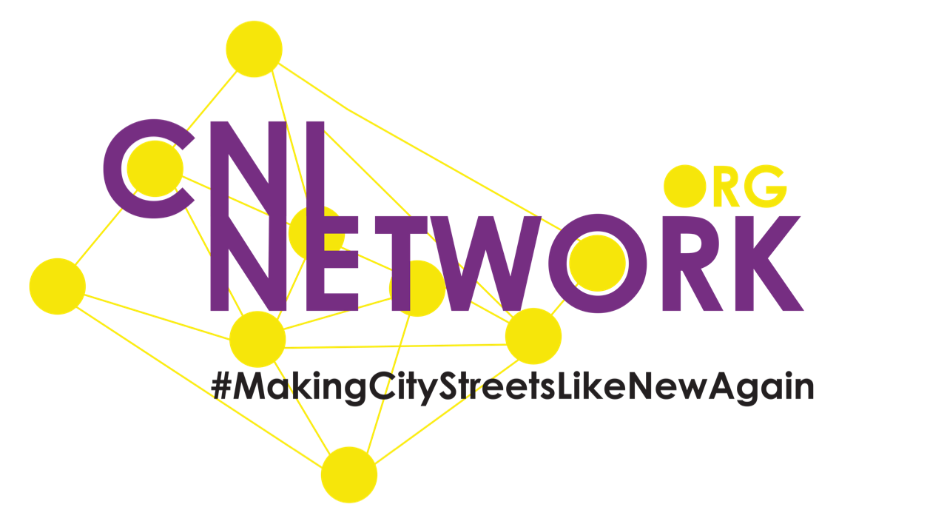
International Day of Prayer for the Night-time Economy
Sunday 24th February 2019 - Resources for Church Services

Bible Passage:

Your people will rebuild the cities that were destroyed long ago.
And you will build again on the old foundations.
You will be called the one who repairs broken walls.
You will be called the one who makes city streets like new again.

Isaiah 58:12 - The Bible

#BeTheOne #MakingCityStreetsLikeNewAgain

Introduction:

Every week teams of amazing people give up weekend evenings to head into town and city centres to serve and love those who are enjoying the night-time economy. Through Street Angels, Club Angels (and in summer Festival Angels) these teams have helped change a culture as violence and anti-social behaviour and alcohol related A&E admissions are reduced. Our teams help whoever needs help or whoever could become vulnerable. We work with the Police, ambulance and paramedics, local councils, BID teams, Purple Flag, doorstaff and pub / club staff and managers to create a night-time economy where people feel safe and can enjoy.

You may want to invite a speaker from one of our local projects to share more about the work that happens locally (see cninetwork.org/projects) or simply show one of the videos or include the prayer below.

Video Resources:

www.cninetwork.org/blog/new-videos-for-cni-network-from-radio-yorkshire - 2 videos featuring an interview with Paul Blakey MBE talking Street and Festival work

https://youtu.be/Wm30JQ5QFZI - BBC’s Songs of Praise feature Street Angels Magaluf

www.youtube.com/watch?v=HfG1mymgh6k - BBC Newsnight feature Street Angels Magaluf

https://youtu.be/udj0d_rG2GU - BBC Street Patrol follows a Club Angels team

www.youtube.com/watch?v=ia1xyL0OE-A - Festival Angels at work, Leeds Festival

Prayer Pointers:

Include the points of the celebration:

- work we do on the streets, in clubs and at festivals
- those we help
- our volunteers in our 130 local CNI projects and for those who volunteer as Street Pastors, homelessness work, addiction support, etc
- great partnerships with a wide range of organisations
- that alcohol related violence and A&E admissions are reducing year on year in the UK
- that the church is at the heart of change within the night-time economy

Include the points for prayer:

- further significant reductions in violent crime and anti-social behaviour
- the night-time industry and its workers
- situations around human trafficking, binge drinking, depression, etc
- CNI Network as we expand to new towns and countries and support new project ideas
- partner organisations including Police, Fire, etc and for improved links
- work with young people around alcohol and safety
- finances for local projects and the international CNI Network
- that people will have a SafeNightOut.party with no incidents or injury

Prayer:

Lord as we pray ‘God’s Kingdom come, God’s will be done, on earth as in heaven’ help us to be people who make that a reality for our communities. We thank you for the work that happens at night in communities across the UK and overseas to help make this prayer a reality. We pray for every single person who has received help from one of the Street, Club or Festival Angel volunteers. We pray for those caught up in a life of addiction - that freedom may be found. We pray for those who volunteer to serve you at night - for strength, energy and wisdom. Thank you that alcohol related crime and A&E admissions are reducing in the UK year on year - we give you the glory Lord for this, the changed lives and changed communities. Amen!

Web Sites:

CNI Network:
www.cninetwork.org.uk / www.facebook.com/cninetwork / www.twitter.com/cninet

SafeNightOut.party:
www.safenightout.party

Please share your local project, SafeNightOut.party, #CNIPrayer and CNI Network on your church social media.

Other:

CNI Network also run Love Your Streets - a Lent campaign which encourages people to #Do1NiceThing every day in Lent - details are at www.do1nicething.org.uk

CNI Network are one of the partners on #FaithAndPoliceTogether - a collaboration of faith based initiatives working with the Police on Policing Priorities. Check out www.faithandpolicetogether.org.uk for more details and do think of ways you as a church can engage better with your local Police towards wider community transformation.

