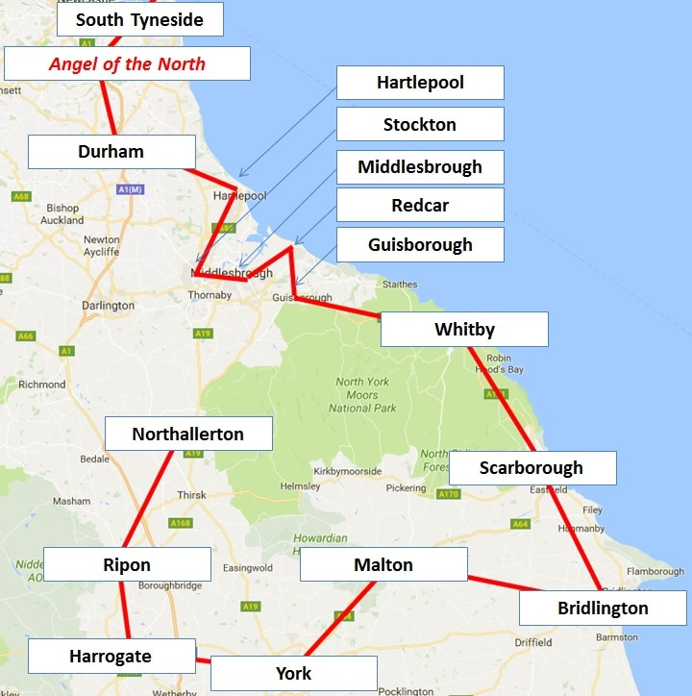
234 miles

15 CNI Network local projects

3 days

2 cyclists

On Friday 9th June, CNI Network Trustee Steve Brock and Stockton Town Pastor volunteer Andy Fox set of on a 3 day 234 mile cycle challenge visiting 15 CNI Network projects along the way!

Find out more at www.cninetwork.org/cycle

To sponsor them text DUCK22 £amount
(eg £3, £5, £10) to 70070 or visit the website

Come and cheer them on when they visit << TOWN >>

Come and meet the cyclists, CNI Network founder and your local << NAME OF PROJECT >> team:

<< VENUE >> << DATE >> << TIME >>

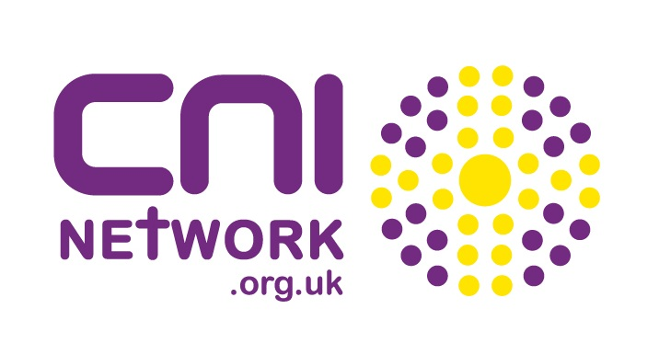
CNI Network - registered charity 1136416 / Company Limited by Guarantee 07173090

