Street Angels take to their bikes!
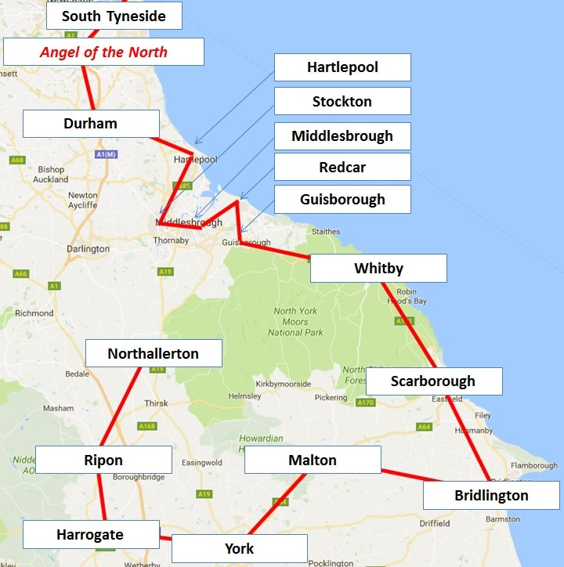
Two Angels are taking to their bicycles in June to cycle 234 miles visiting 15 CNI (Christian Nightlife Initiatives) Network projects across the North East of England, including our very own << PROJECT NAME >>

The pair, Steve Brock and Andy Fox both from Stockton, will leave South Tyneside at 9.30am on Friday 9th June and will arrive three days later at 4.15pm in Northallerton. They will be joined by the founder of Street Angels, Paul Blakey MBE (though he is part of the support team not cycling!) As you may know the North East of England is known for its hills and the North York Moors on day 2 will be a particular challenge! Along the way they will visit iconic landmarks (such as Angel of the North, Middlesbrough Transporter Bridge, Whitby Abbey and York Minster) and meet local volunteers.

The aim of this epic cycle ride is to raise awareness and funds for CNI Network and the 15 local projects. For more details, to sponsor the pair or to follow the progress visit www.cninetwork.org/cycle or facebook.com/cninetwork

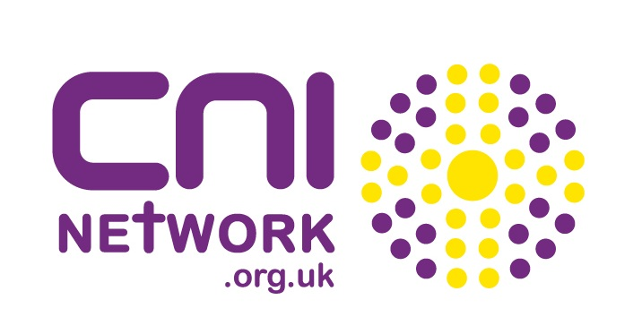
The team will be in << TOWN NAME >> at << LOCATION >> on << DATE >> at << TIME >>. People are invited to come and cheer the team on and find out more about CNI Network and << LOCAL PROJECT >>.

The ride is sponsored by Access Insurance www.accessinsurance.co.uk

